Dear Friends,

Our new episode for the 3rd Sunday of Lent is now live on our website. This week, the Sunday Gospel tells the story of Jesus driving the market traders and money changers out of the Temple. Greg gives a challenging teaching and stresses the importance of praying with our hearts rather than for appearances.

Series Four - Lent 2021 — The Mark 10 Mission.

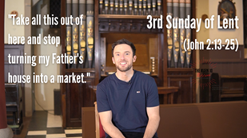

There is once again a 'Weekly Mission' poster for this episode in our resources section.

Thank you for your wonderful support and we hope you have a blessed week in school.

God bless you,

The Mark 10 Team

