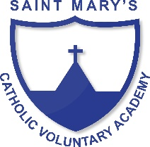
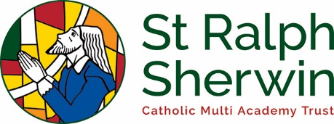
Art and Design Long Term Plan Class 3

 | Year A  (2019/20) | Year B  (2020/21)
Advent 1 | Anglo Saxons/ Vikings  DRAWING – sketching portraits (pencil and charcoal)  TEXTILES – weaving jewellery or clothing | Iron Age/ Stone Age  A study of early British life up to and including the Celts  DRAWING– cave painting with charcoal
Advent 2 | Were rocks ever alive?  SCULPTURE - Rock stone sculptures and clay fossils | Digestive system  COLLAGE – use a variety of materials to create a model of the digestive system
Lent 1 | Are you hearing what I hear?  DRAWING – create an image to match a piece of music | Italy  WORK OF OTHER ARTISTS/PAINTING - Sistine Chapel – Michelangelo – painting techniques
Lent 2 | What has a mouth but does not eat….?  A study of rivers – including the River Goyt and the River Nile  PAINTING - Monet and the River Thames | Romans  COLLAGE - Making Mosaics
Pentecost 1 | Egyptians  SCULPTURE - Clay scarab beetles  and paper mache Canopic jars  PRINTING – Egyptian hyrogliphs | Volcanoes/ natural Disasters  WORK OF OTHER ARTISTS/COLLAGE - Collage based on work by Margaret Godfrey
Pentecost 2 | How does your garden grow?  PAINTING - landscapes  WORK OF OTHER ARTISTS - Vincent Van Gogh - Sunflowers | Iron man  (Forces and magnets)  SCULPTURE - metal sculptures  WORK OF OTHER ARTISTS/PAINTING - Jackson Pollock – abstract expressionism – using gravity to create splatter paintings

