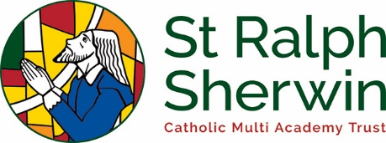
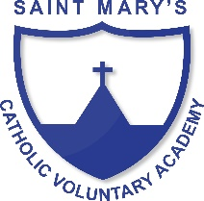
Art and Design Long Term Plan Class 4

 | Year A  (2019/20) | Year B  (2020/21)
Advent 1 | Ancient Islamic culture  PRINTING - Patterns and tessellations using geometric shapes  COLLAGE - Create a mosaic | Victorians  WORK OF OTHER ARTISTS/TEXTILES/COLLAGE/PRINTING - William Morris patterns
Advent 2 | Could you survive without electricity?  CHRISTMAS ACTIVITIES – CARDS, CLAENDAR DECORATION ETC | Local geography study  WORK OF OTHER ARTISTS/PAINTING - LS Lowry
Lent 1 | Why doesn’t crime pay?  Crime and punishment through the ages.  SCULPTURE - Roman Curse Tablets | Is there anyone out there?  (A study of outer space and light)  SCULPTURE - Modroc sculpture of planets
Lent 2 | Why do veins look blue – but blood is red?  A study of the human circulation system  DRAWING - Sketching and annotating drawings of the heart. | Ancient Greece  SCULPTURE/PAINTING - Pottery, portraying humans in action red terracotta with black painted images
Pentecost 1 | Properties and changes in materials  COLLAGE - Using recycled materials to create a piece of art | New Mills or New York? (Greatest Showman)  PAINTING – Local landscapes
Pentecost 2 | Brazilian rainforests  WORK OF OTHER ARTISTS– Romero Britto | What would happen if we didn’t look after the world?  Evolution  DRAWING – sketching images of human evolution/silhouettes

