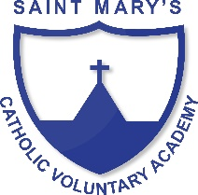
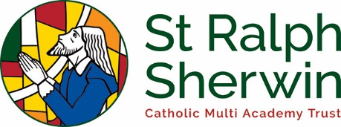
Art and Design Long Term Plan Class 3

 | Year A  (2019/20) | Year B  (2020/21)
Advent 1 | Anglo Saxons/ Vikings  Build model Viking longhouse | Iron Age/ Stone Age
Advent 2 | Were rocks ever alive? | Digestive system  Cooking and Nutrition – design and make foods
Lent 1 | Are you hearing what I hear?  Design and make musical instruments that can play at different pitches | Italy  Cooking – Italian dishes
Lent 2 | What has a mouth but does not eat….?  A study of rivers – including the River Goyt and the River Nile  Make boats that float from natural resources | Romans  Building chariots
Pentecost 1 | Egyptians | Volcanoes/ natural Disasters
Pentecost 2 | How does your garden grow? | Iron man

