|  |  |  |  |
| --- | --- | --- | --- |
| Key knowledge |  |  |  |
| Reception  Listen to spoken language, be able to participate in basic games where understanding of language is shown. Be able to show understanding by participation. | Applied and revisited orally through practice and repetition throughout the year.  Counting songs, Greeting songs  Register –greet in French  Numbers 1-10  Bonjour  Au revoir  Ecoutez  Silence  Levez vous  Asseyez- vous | | |
|  | Autumn | Spring | Summer |
| Listen attentively to spoken language and show understanding by joining in and responding | Greetings  Revisit EYFS key words  Numbers 1-10  Bonjour  Au revoir  Merci  S’il vous plait | Numbers 1-10 including zero  Days of the week  Months of the year  Feelings | Class room commands  Ecoutez, levez-vous, asseyez- vous  Revisit greetings and number within 10  Colour |
|  |  |  |  |
| Explore the patterns and sounds of language through songs and rhymes and link the spelling, sound and meaning of words | Revisit year 1 objectives at the start of each lesson  Greetings  Bonjour. Ca va? Ca va bien merci! | Numbers 1-10 including zero | Class room commands  Ecoutez, levez-vous, asseyez- vous  Revisit greetings and number within 10 begin to identify spoken word with written word |
|  | |  | |

**KS1 Introduction to French**

**KS2 Medium and Long term planning**

The Primary French Project modules have been carefully written (Niveau Bleu:Y3; Niveau Blanc:Y4) to provide small progressive steps forward in vocabulary, grammar and language learning skills, with many opportunities to revisit and revise.

• Niveau Bleu and Niveau Blanc modules have been ‘mixed and matched’ to create a two-year rolling programme: Yr A & Yr B for mixed-age classes.

• Medium term planning pages are provided for each module (pages 4-17) with detailed mixed-age planning guidance

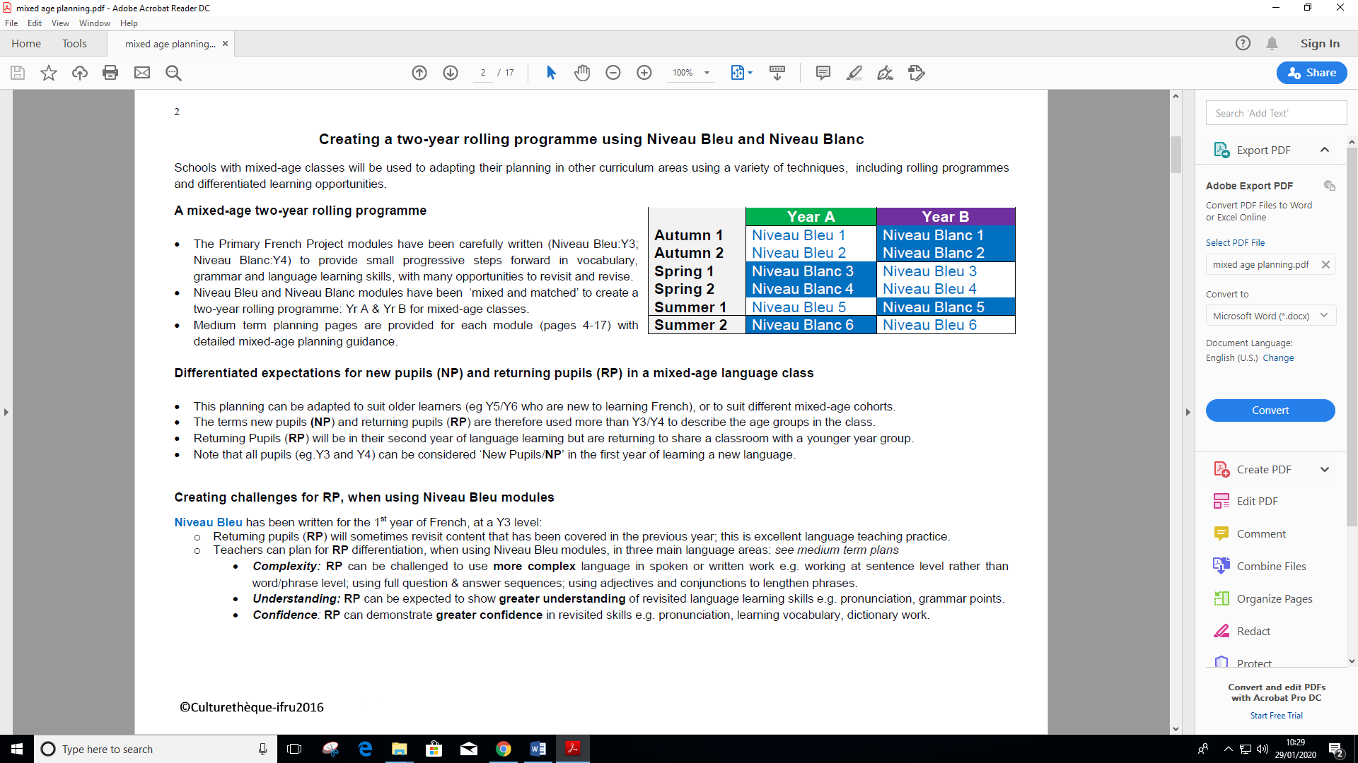

The Primary French Project modules (Niveau Rouge: Y5 / Niveau Tricolore: Y6) have been carefully written to provide small progressive steps forward in vocabulary, grammar and language learning skills, with opportunities to revisit and revise.

• Niveau Rouge and Niveau Tricolore modules have been ‘mixed and matched’ to create a two-year rolling programme: YC/D for Y5/6 mixed-age classes.

• This follows on from the YA/B rolling programme for Y3/4 using Niveau Bleu and Niveau Blanc.

• Medium term planning pages are provided for each module (pages 4-17) to give detailed mixed-age planning guidance.

