|  |  |
| --- | --- |
| **Celebrate:**  **How do we act as Christians?** | |
| The Church uses purple and ashes as signs of Lent and being sorry. |  |
| Representations of Holy Week and Easter: palms, the cross, Easter gardens, and symbols of new life. |  |

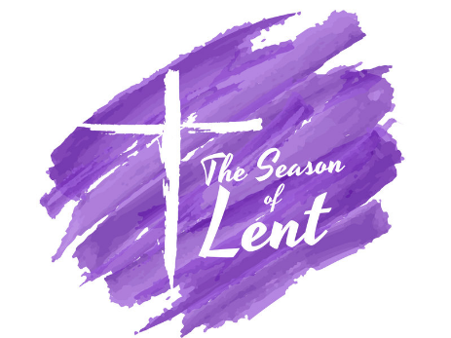

|  |  |
| --- | --- |
| **Hear:**  **What Scripture will we Hear?** | |
| A simplified version of key events of Holy Week especially Good Friday and Easter Sunday. |  |
| The great commandment (Lk 10:25-28) |  |

|  |  |
| --- | --- |
| **Live:**  **How do Catholics live out their Faith?** | |
| Various cultures celebrate Lent and Easter in different ways, for example: pancakes, hot cross buns, Easter eggs. |  |
| Trying to help others by what we do in Lent. Could include Raasa Parade (Kerala) and other Lent customs around the world. |  |
| Some people have what they need, but many people don’t. Jesus wants the people who already have what they need to help these others. Jesus wants us to take care of this. |  |

|  |  |
| --- | --- |
| **Believe:**  **What do Christians Believe?** | |
| Listen to and talk about the season of Lent and Easter. |  |
| Jesus died on Good Friday and rose again on Easter Sunday. |  |
| Easter is a celebration that Jesus is with us still. |  |
| Easter celebrates new life. |  |
| Simple religious symbols in Lent and Easter |  |

**Key Vocabulary**

Holy Week Easter Lent

Good Friday new life

palms sorry

