Long Term plan Year A Overview: Class 1

Term | RE | Maths | English | Science | History | Geography | PSHE & RSE  Ten Ten | Art/DT | Computing | Music | PE
Advent 1 | 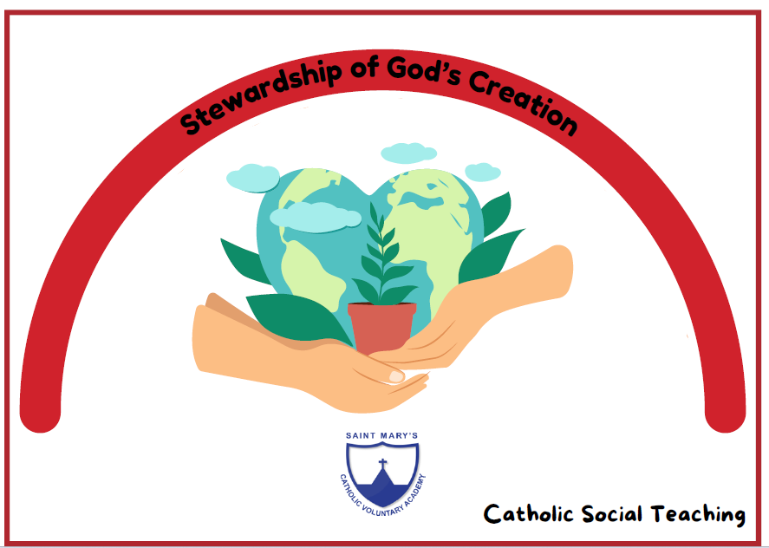  Branch 1 Creation and covenant | Getting to know you  Match, sort, and compare.  Talk about measure and patterns | Three Billy Goats Gruff  What ever next  Aliens love underpants | 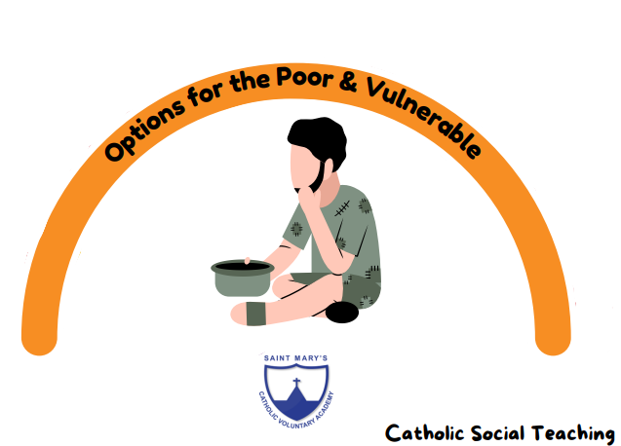  Uses of Everyday Materials  (Y1) | 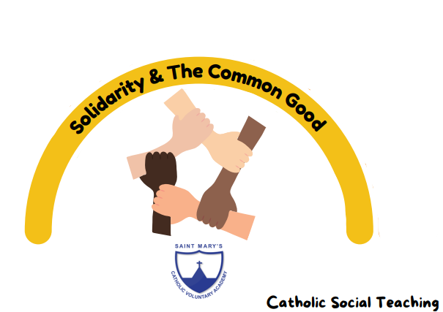  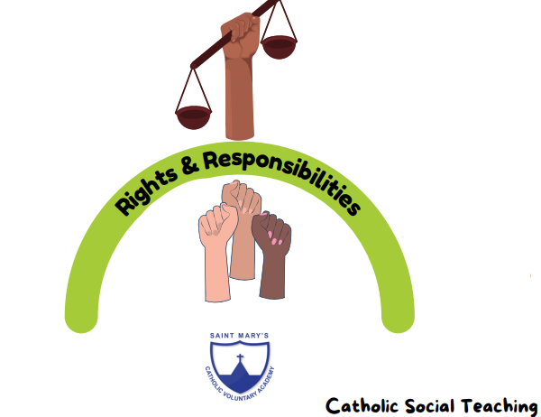  The History of Space |  | Module 1: Created and Loved by God | 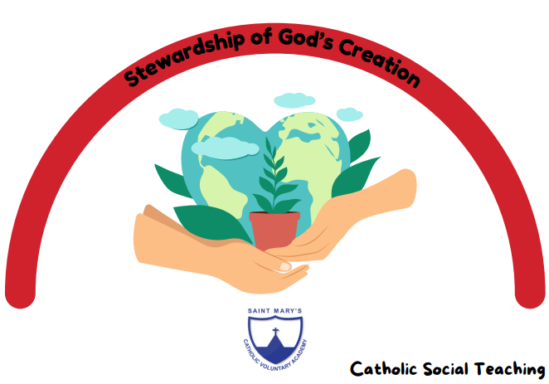  Art Fundamentals | Technology around us | I’ve got a grumpy face  The sorcerer’s apprentice | Introduction to PE: Unit 1
Advent 2 | Branch 2 Prophecy and promise  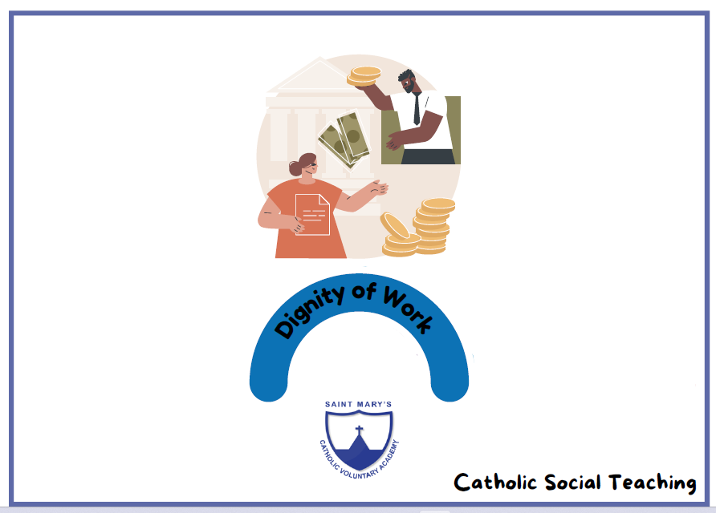 | Its Me 1,2,3  Circles and triangles  1,2,3,4,5  Shapes with 4 sides | Pirate book  We’re going on a bear hunt,  Season Poem | Seasonal changes  (Y1) |  | Maps  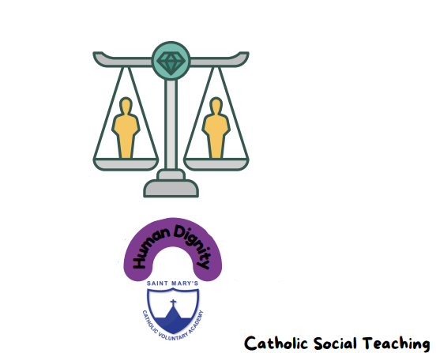 |  | What can we see? | Digital painting | Witch, witch  Row, Row, Row your boat | Introduction to PE: Unit 2
Lent 1 | Branch 3 Galilee to Jerusalem  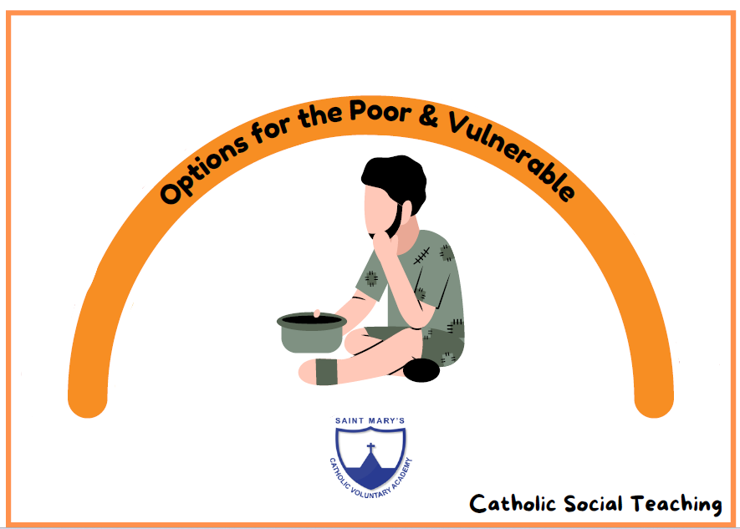 | Alive in 5  Mass and capacity  Growing 6, 7, 8  Length, height, and time | Pass the Jam Jim  Pigs Might Fly | Animals inc Humans  (Y1) | The History of Flight |  | Module 2: Created to Love Others  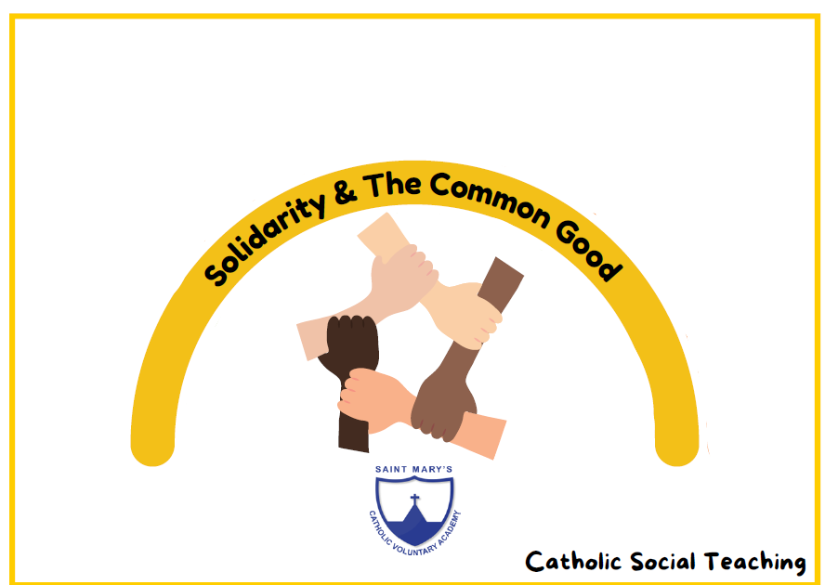 | How can we explore colour? | Digital writing | Bird spotting: Cuckoo polka  Shake my sillies out | Gymnastics: Unit 1
Lent 2 | Branch 4 Desert to garden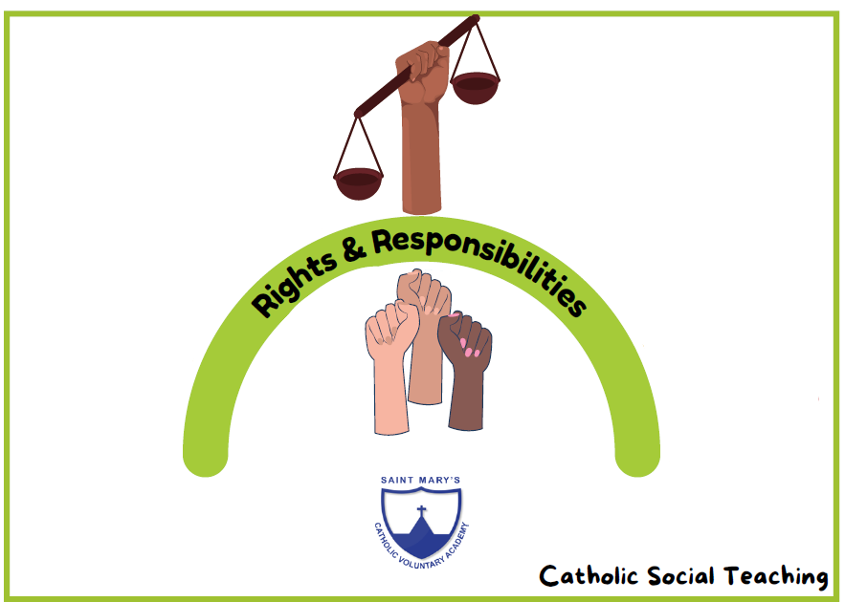 | Building 9 and 10  Explore 3-D shapes | Queens Hat  Hungry caterpillar  The bad tempered lady bird  Egg hunt | Animals inc Humans (Y1) |  | Th United Kingdom |  | How can we explore marks & prints? | Grouping Data | Up and down  Five Fine Bumble Bees | Dance: Unit 1
Pentecost 1 | Branch 5 To the ends of the Earth  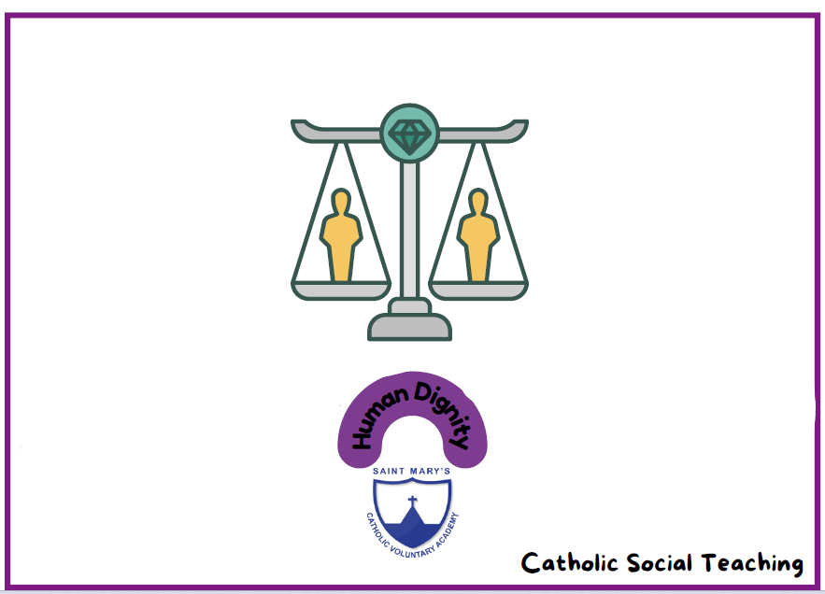 | To 20 and beyond  How many now?  Manipulate, compose, and decompose | The Tiny Seed  Olivers vegetables | Plants  (Y1) | The Great Fire of London |  | Module 3: Created to Live in Community  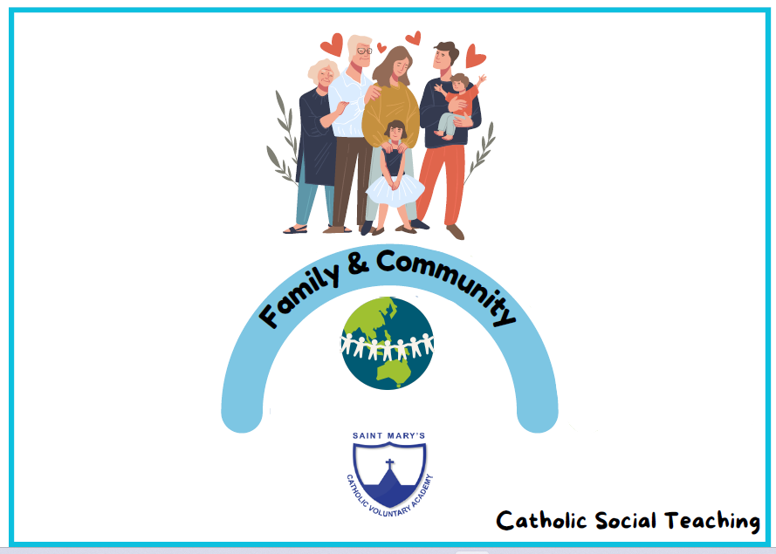  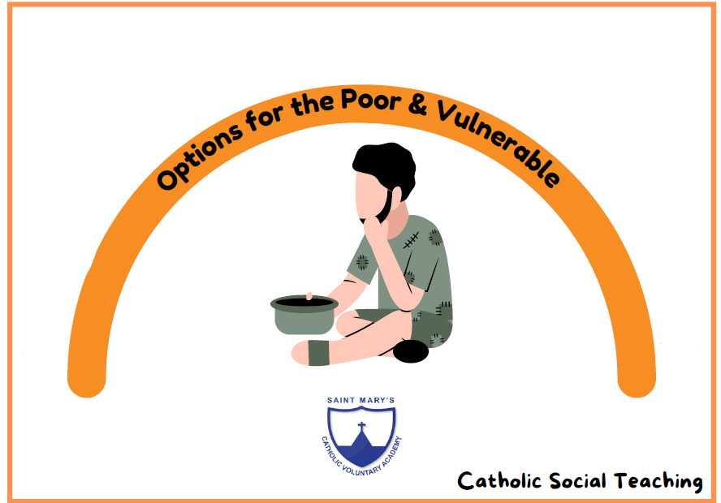 | How was we use our imaginations? | Moving a Robot | Down there under the sea  Oh, its quiet | Fundamentals Unit 1
Pentecost | Branch 6 Dialogue and encounter | Sharing and grouping  Visualise, build and map  Make connections |  | Working Scientifically |  | Africa |  | How can we build worlds? | Introduction to animation | Slap, clap, clap  Bow, bow, bow Belinda | Games: Unit 1  