Long Term plan Year A 2025/2026 Overview Class 3 Mrs Chapman/ Miss Baythorpe
Term | Maths | English | Science | Computing | RE | History | Geography | Art/ D&T | French | Music | PE | PSHE
Advent 1 | Place Value  Addition  Subtraction | The Heart and the Bottle – Settings  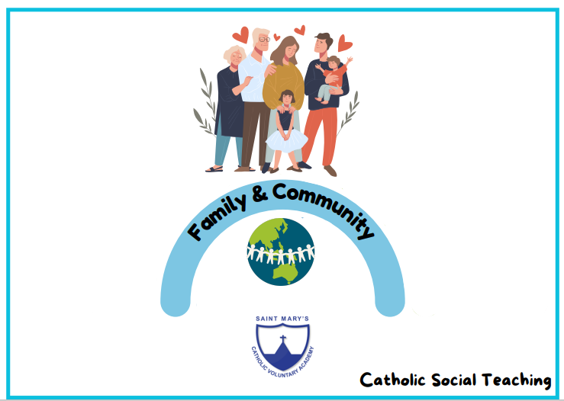  Instructions |  | The Internet  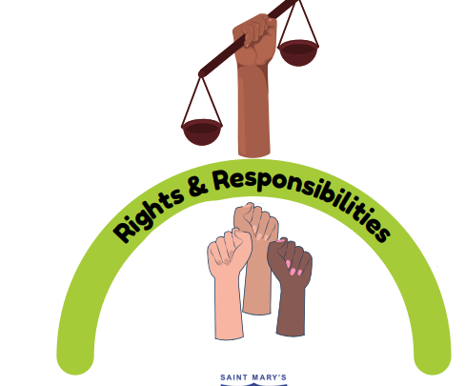 | 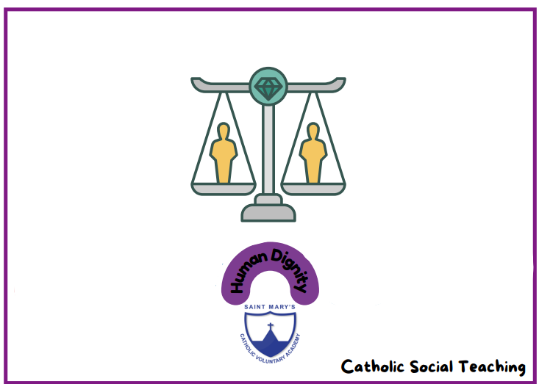  Creation & Covenant | Ancient Egyptians  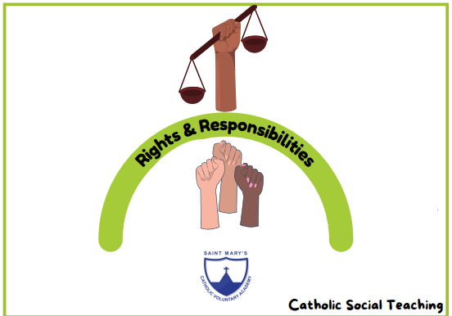 |  | Print making Collage  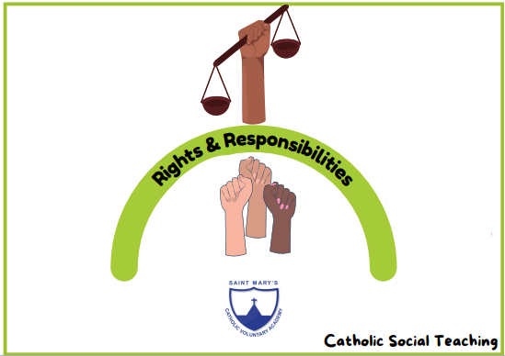 | Greetings   | I’ve been to Harlem | OAA  Basketball | Module 1  Created and Loved by God  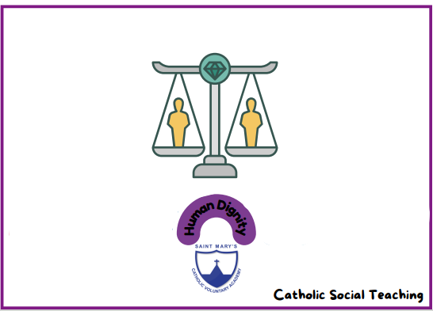
Advent 2 | Addition  Subtraction  Multiplication | The Iron Man  Suspense  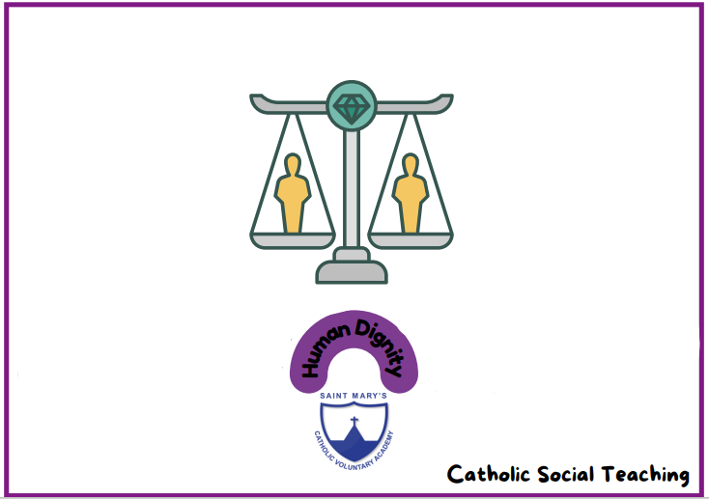  Recount | States of Matter  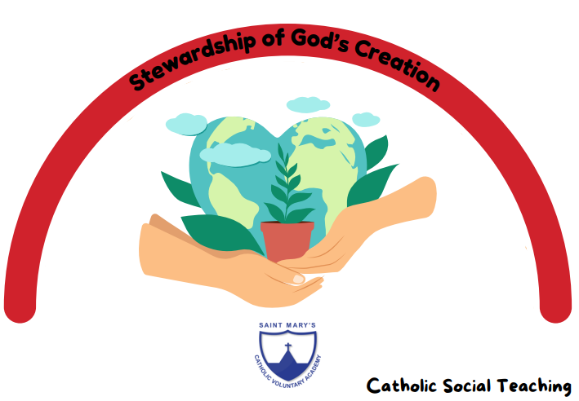 | Audio Editing | Prophecy and promise |  | Rivers | Drawing Sculpture Sketchbooks | Uk place names  Asking questions | Chilled-out clap rap | Fitness  Fundamentals | Module 1  Created and Loved by God
Lent 1 | Multiplication  Division | The Rhythm of the Rain  Openings and Endings  Explanations | Plants | Photo editing | Galilee to Jerusalem | Vikings |  | Painting, Drawing, Sewing, Sketchbooks | Classroom instructions   | Latin dance (Classroom percussion)* | Dance  Gymnastics | Module 2  Created to Love Others  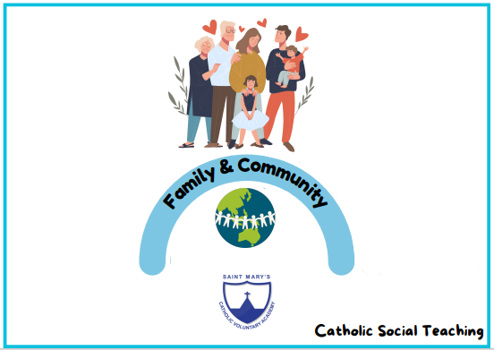
Lent 2 | Fractions  Decimals | Flotsam  Description  Tin Forest  Persuasion/Information | Living things and habitats | Data logging | Desert to garden |  |  | Drawing, Sketchbooks, Sculpture   | Paris landmarks | ‘March’ from The nutcracker  From a railway carriage | Athletics  Ball skills | Module 2  Created to Love Others
Pentecost 1 | Measure:  Time  Money  Length  Mass and capacity | The BFG  Characterisation  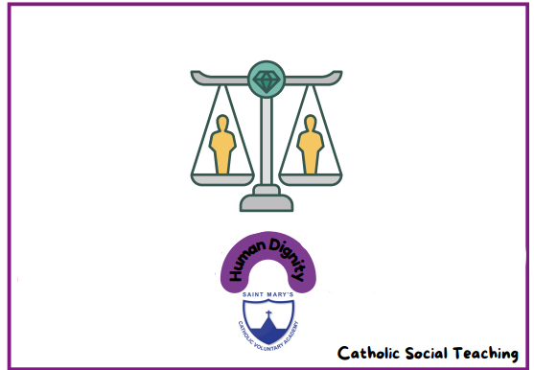  Information | Electricity | E-safety  Repetition in shapes  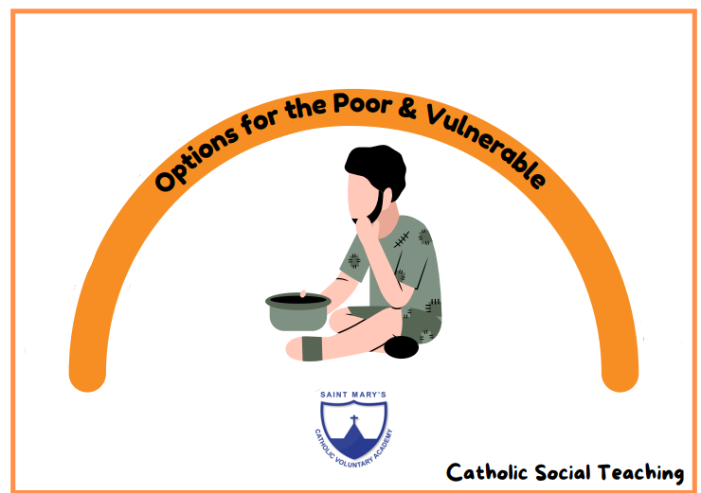 | To the ends of the Earth | Tudors |  | Cyanotype, Anthotype, Painting with Natural Pigments, Drawing, Sketchbooks | How old are you?  Where to you live?  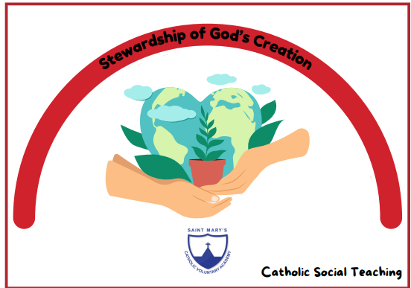 | Just three notes  Samba with Sérgio | Dodgeball  Swimming | Module 3  Created to Live in Community
Pentecost 2 | Geometry:  Angles and triangles  Position and direction | Black Dog  Dialogue    The Tear Thief  Persuasion | Light and Sound | E-safety  Repetition in games | Dialogue and encounter |  | Rainforests | Painting, Drawing, Collage, Sketchbooks, Relief | London Landmarks   | Fly with the stars (Classroom percussion)* | Tennis  Swimming | Module 3  Created to Live in Community

