Term | Maths | English | Science | Computing | RE | History | Geogra-phy | Art/ D&T | French | Music | PE | PSHE
Advent 1 | Place Value  Addition  Subtraction | Main Text: ‘The First Drawing’  by Mordicai  Gerstein  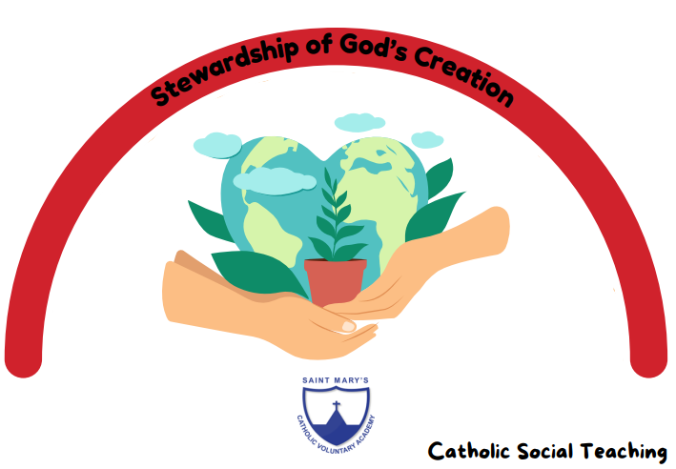  Text: How to wash a Woolley Mammoth  Poetry – I was born in the stone age | Rocks and Fossils | Connecting  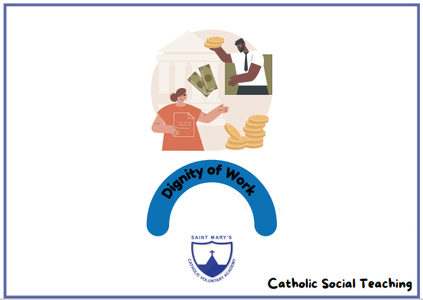  Computing |   Creation & Covenant | 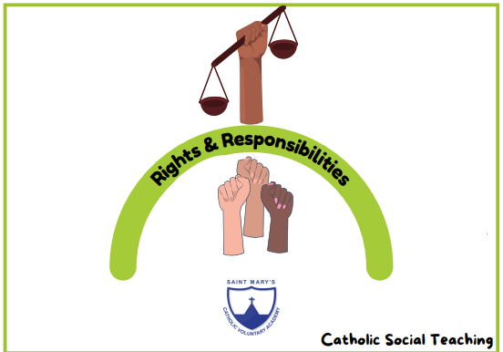  Stone Age to Iron Age |  | Stone Age Access Art | Talk about myself  My pets  At home   | This little light of mine* | OAA  Fundamentals  Y3/4 | Created and Loved by God
Advent 2 | Addition  Subtraction  Money | Main Text: ‘The Wilderness’ by Steve McCarthey  Text: Eat Healthy!  Persuasive writing  Christmas poetry | Teeth and Eating including the digestive system |   Animation | Prophecy and promise |  | Italy | Festival Feasts  Food Technology | Going to school  In the Classroom  Christmas | My fantasy football team | Fitness  Gymnastics | Created and Loved by God
Lent 1 | Multiplication  Division | Portal story – characterisation  Information texts |  | Desktop Publishing | Galilee to Jerusalem | Romans |  | Exploring Pattern  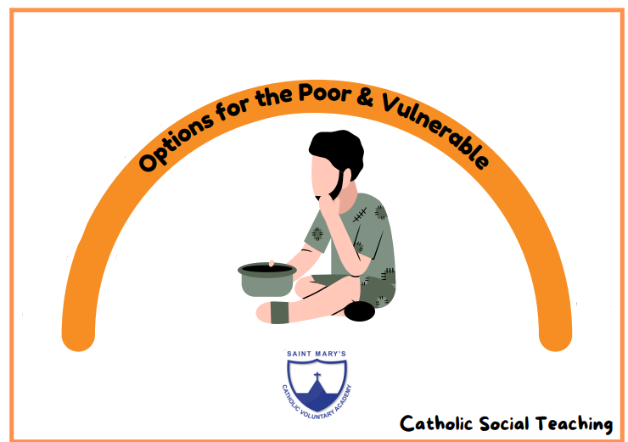 | In the classroom  Lunch at school | The doot doot song (Classroom percussion)* | Athletics  Dance | Created to love others
Lent 2 | Fractions  Decimals | Fantasy story – description  Recounts |  | Branching Databases | Desert to garden |  | Volcanoes | Storytelling through Drawing  Chariots and Mozaics | School subjects  Sports and hobbies | ‘Fanfare for the common man  Spain | Ball Skills  Y3/4  Golf | Created to love others
Pentecost 1 | Measure:  Time  Length  Mass and capacity | Adventure story – dialogue  Explanations | Forces and Magnets | Sequence in Music | To the ends of the Earth |  | Extreme Earth | Making animated drawings | Play an instrument  The weather & seasons | Global pentatonics  The horse in motion | Rounders  Swimming | Created to Live in Community
Pentecost 2 | Geometry:  Angles and triangles  Position and direction | Suspense  Discussions |  | Events and Actions | Dialogue and encounter | Plague |  | The Art of Display  Erupting Volcanoes | Fruit and at the market | Favourite song (Classroom percussion)* | Tennis  Swimming | Created to Live in Community

