1. | Jesse tree | A way of preparing during Advent by journeying through the bible stories from Jesus’ family tree.
2. | Ancestry | The genealogy (family tree) of Jesus.
3. | Advent | The first season of the Church’s year and a time of waiting for the coming of Jesus at Christmas.
4. | Incarnation | God became man in the body of Jesus Christ. Jesus was both fully human and fully God at the same time.
5. | The Jesse tree represents the ancestry of Jesus using artistic symbols starting with creation and ending with the incarnation.
6. | The Jesse tree tradition is rooted in Isaiah 11:1 “A shoot shall come out from the stump of Jesse, and a branch shall grow out of his roots.”
7. | Jesse was the father of David, Israel’s greatest king.
8. | The meaning and representation of the Jesse tree connects to God’s plan for salvation.
1. | Elijah was a prophet who called the people of Israel to return to God.
2. | The story of Elijah can be found in the book of Kings in the Old Testament. (1Kings 17-19)
3. | Prophet | A person who delivered a message they received from God to the people.
4. | Historical context | Events in History that influenced what was written and who it was written for.
5. | Elijah | A prophet from the Old Testament.
6. | Miracle | An extra ordinary event taken as a sign of the power of God.
7. | Prophecy | Reflects communication messages between God and humans through the prophets.
8. | Encounter | Recognising God’s presence in our own lives and moments when we have a personal encounter with God.
9. | Messiah | A saviour of a group of people. The ‘anointed’ one.
10. | John the Baptist | He was the last prophet of the Old Covenant who devoted his life to preparing the way for Jesus.
11. | Covenant | A promise or an agreement.
12. | Preaching | Teaching and spreading the Good News of Jesus.
13. | Elijah’s story shows the importance of faith and hope in God even in desperate times.
Christ the King
Elijah and John the Baptist - Prophets
The Jesse Tree
1. | Christ the King | Jesus Christ is not an earthly king, but the divine king of the universe who unites all of creation with God the Father.
2. | Liturgical year | Shows the Church’s seasons throughout the year.
3. | The feast of Christ the King | This marks the end of the Church’s year and describes what is celebrated.
 | 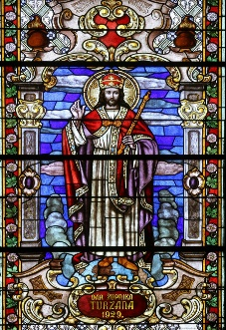 | 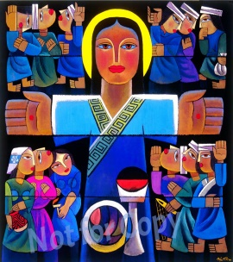
 | 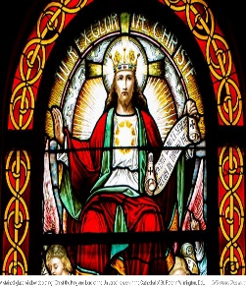 | 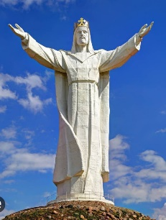
4. | Religious art work is used to celebrate the feast of Christ the King.

