1. | Feast of Christ the King | Feast of Christ the King, also called Solemnity of Our Lord Jesus Christ, festival celebrated in honour of Jesus Christ as lord over all creation. It serves as a reminder to be thankful for Christ's unselfish act in securing mankind's survival.
2. | Magnificat | Mary's song of joy draws heavily from the Old Testament to show how her son will fulfil many of God's promises.
3. | Vespers | A liturgy of evening prayer. The word for this prayer time comes from the vesper, meaning "evening".
4. | Mary fulfilled the Old Testament as it is expressly predicted in Isaiah 7:14: "Behold, a virgin will be with child and bear a son, and she will call His name Immanuel" According to Matthew 1:22-23, this prophecy was fulfilled in Mary.
5. | There are still women today who continue to fulfil God’s work: Benedictines, Bridgettines, Sisters of the Blessed Virgin Mary
1. | Infancy | The earliest stage of a child's life.
2. | Narrative | A piece of writing that focuses on telling a story.
3. | Luke 1:26-56 | Gabriel tells Mary that the Holy Spirit is going to cause her to be pregnant. He goes on to tell her that God had performed a miracle with Elizabeth as well.
4. | Matthew 1:18-25 | Joseph decided to break his engagement to Mary quietly. However, an angel appeared to him in a dream, telling him to marry Mary. The angel said that Mary would have a son, whom they were to name Jesus.
5. | 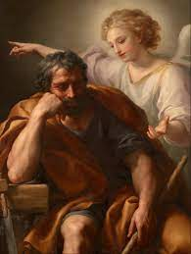  The Dream of Saint Joseph- Anton Raphael Mengs | The Annunciation- Tanner  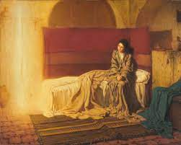
6. | Artwork that depicts and celebrates what is described in Matthew 1:18-25 | Artwork that depicts and celebrates what is described in Luke 1:26-56
1. | Protagonists | Advocate or champion of a particular cause or idea.
2. | Salvation | Preservation or deliverance from harm, ruin, or loss.
3. | Old Testament | The first part of the Bible, which is the holy book of Christianity. It narrates the history, wisdom, and prophecies of the Jewish people, and their relationship with God.
4. | Miriam  Exodus 2:1-10 | She participates with Moses and Aaron to lead the Israelite community during the exodus and the wanderings. Her role in saving her baby brother and in celebrating the crossing of the sea highlights her concern for her people.
5. | Deborah  Judges 4:4-11;  5:7-15 | A prophet, judge and heroine in the Old Testament, who inspired the Israelites to a mighty victory over their Canaanite oppressors.
6. | Esther  Esther 8:3-12 | She becomes queen and risks her life to save the Jewish people from destruction when the court official Haman persuades the king to authorise the destruction against all the Jews of the empire.
Lucan and Matthean Infancy Narrative
Mary the fulfilment of the Old Testament
Women of the Old Testament
