1. | The Pope  The Pope is the leader of the Catholic Church on Earth. He is also called the Bishop of Rome. The first Pope was St Peter, and his authority and infallibility has passed on to all the Popes that have come after him. | 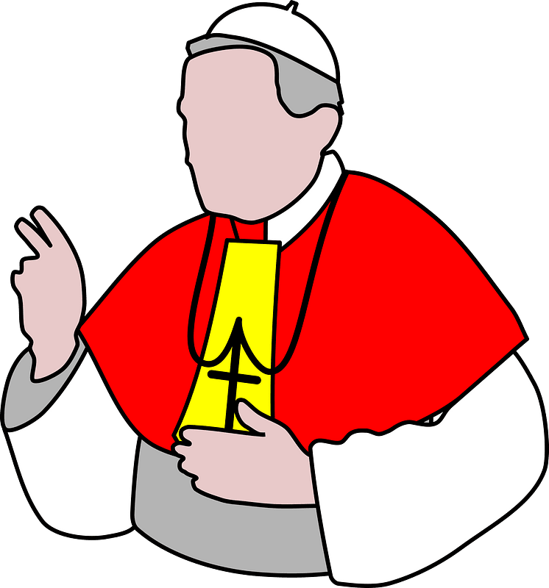
2. | Apostleship  All members of the church are tasked with spreading the good news of Jesus and continuing to build the Kingdom of God. We all called to be part of this mission. | 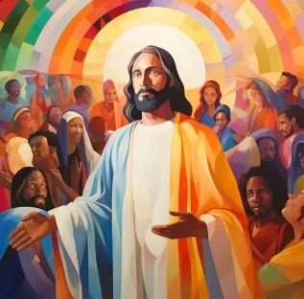
I believe in God,
the Father almighty,
Creator of heaven and earth,
and in Jesus Christ, his only Son, our Lord,
who was conceived by the Holy Spirit,
born of the Virgin Mary,
suffered under Pontius Pilate,
was crucified, died and was buried;
he descended into hell;
on the third day he rose again from the dead;
he ascended into heaven,
and is seated at the right hand of God the Father almighty;
from there he will come to judge the living and the dead.

I believe in the Holy Spirit,
the holy catholic Church,
the communion of saints,
the forgiveness of sins,
the resurrection of the body,
and life everlasting. Amen.
The Apostles’ Creed is a declaration of faith. It outlines what we believe in as Catholics.
1. | Call of the disciples  Luke 5:1-11 | 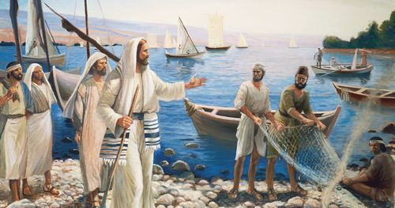
2. | Peter’s Declaration of Faith  Matt 16:13-20 | 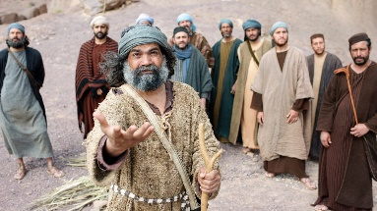
3. | Peter denies knowing Jesus  Matthew 26:69-75 | 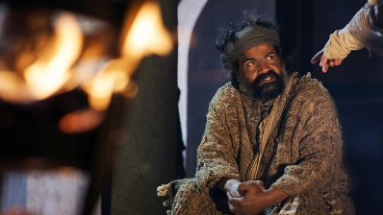
4. | Peter and the tomb  John 20:1-10 | 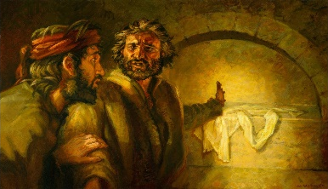
5. | Jesus’ three requests of Peter  John 21:15-17 | 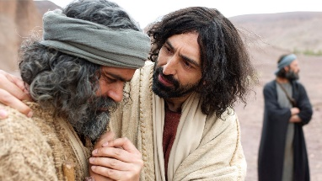
6. | The coming of the Holy Spirit  Acts 2:1-4, 14-21 | 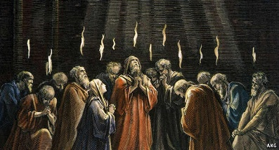
The Apostles’ Creed
The Church on Earth
Life of St Peter
Communion of Saints
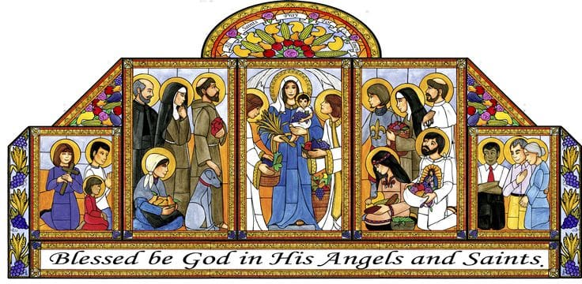
The spiritual union of all believers in Christ, both living and dead, forming one body with Christ as the head.

