1. | Aid to the Church in Need  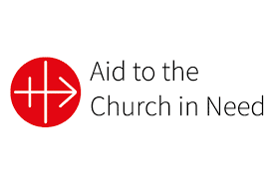 | This charity supports the Catholic faithful and other Christians who are suffering persecution or in need. They offer support people in over 140 countries, including refugees.
2. | Missio   | This charity is the Catholic Church’s official charity for overseas mission. It supports the Church’s work in mission diocese globally to empower local communities.
3. | CAFOD   | This charity is the official aid agency of the Catholic Church in England and Wales. CAFOD offers help to people living in poverty all around the world.
4. | Christian charities | Help people facing injustice and persecution because of their beliefs.
1. | Christian belief | Christians believe Jesus rose from the dead. This is proclaimed in the Apostles’ Creed.
2. | The disciples | The disciples believed that Jesus rose from the dead because they saw Him, spoke with Him, and experienced Him in a different way as being alive.
3. | The Holy Trinity | The Resurrection is the work of the Holy Trinity.
4. | Witnesses to the Resurrection | All Christians are called to witness to the Resurrection by the example of their new life in baptism, strengthened by the Holy Spirit in confirmation.
5. | Martyrdom | Some Christians die for their faith. This is called martyrdom. St. Stephen is the first martyr.
 | 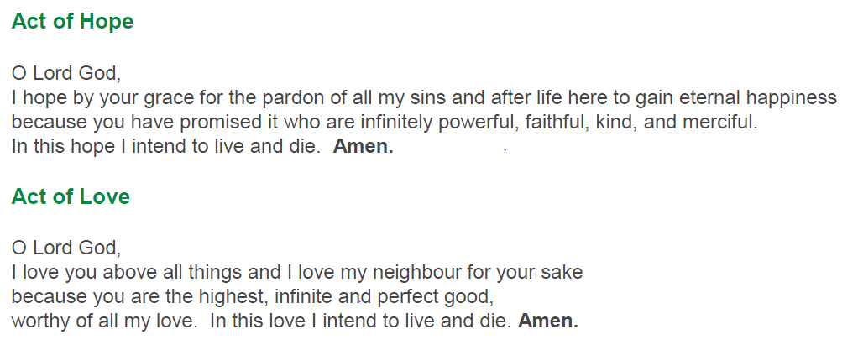
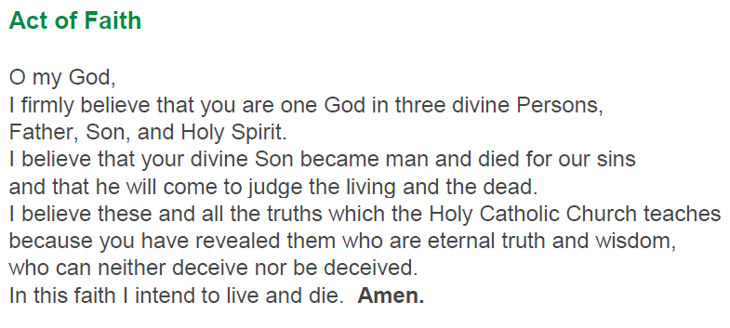
Core Vocabulary
Believe and Celebrate
Christian Charities
1. | Adam | The first man created by God. The ‘new Adam’ refers to Jesus Christ, who through His sacrifice, reverses the effects of original sin and restores humanity to a relationship with God. This contrasts with the first man, Adam, whose actions led to sin and death.
2. | Mary Magdala | Mary of Magdala is mainly known as Mary Magdalene.  Mary is a saint and was a devoted disciple of Jesus. Mary was the first to witness the Resurrection.
3. | Resurrection | Jesus rose on the third day after His crucifixion. The resurrection is the work of the Holy Trinity.
4. | Martyr | Someone who dies for their faith. They bear witness to the truth of the Gospel, which can lead to their death. Some martyrs also experience persecution or violence because of their faith. St Stephen is known as the first martyr.
5. | Witness | Someone who publicly proclaims their faith in Jesus through their words and actions.
6. | Saint | A person recognised as living a life of heroic virtue and now resides in heaven after being canonised.
7. | Charity | A theological virtue. Charities show acts of giving and compassion motivated by faith and love.

